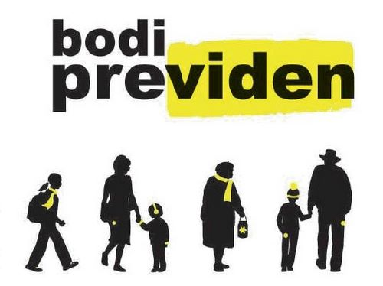

Behu i dukshem -
Behu i kujdesshem!

Be visible -
Be safe!

Bodi Viden -
Bodi Previden!

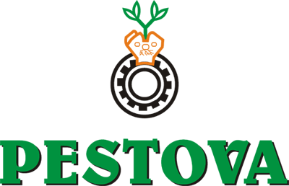
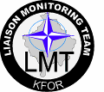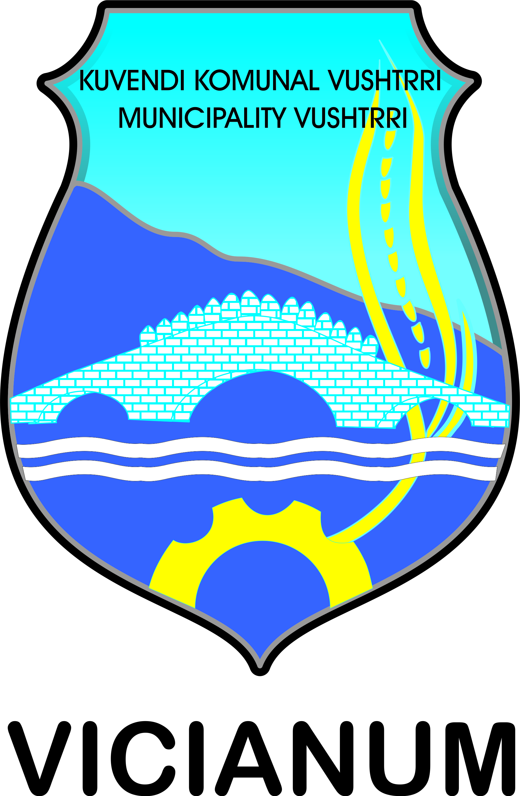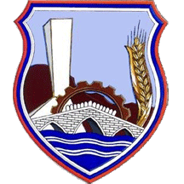
The safety of our kids must be always on the first place.

Dear honored,
It is our pleasure to invite you to the event
”BE VISIBLE – BE SAFE”

Event will be on 16JAN13 at 12:30 HRS in primary school “Naim Frasheri“ in Vushtrri/Vucitrn.
This event is organized with initiation of SVNKON 26 KFOR / LMT N-3, financial support of VIPA CHIPS Factory and Slovenian Public Agency for traffic safety and with moral support of Vuhtrri/Vucitrn municipality.
We think about Kosovo citizens
Safety promoter / LMT N-3

